Development Diary
Day 1:
Created a new project using ASP.NET core web App (Model-view-controller), this gives me a solid foundation to work off of and properly create a good solution for the client.
I used the .NET 9.0 frame work as it is the most stable at the moment. I also selected individual accounts as the solution does require individual accounts to meet the standard of the client. Individual accounts being my authentication type gives me an application with an already working and secure account registration system implemented and I need to add little alterations to it to fit my needs, improving the efficiency and security of the site.
Next I created my models.
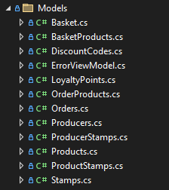
I decided to create a stamps model as an additional feature for the client as I think this will be useful to them and make the solution overall better for customer use.
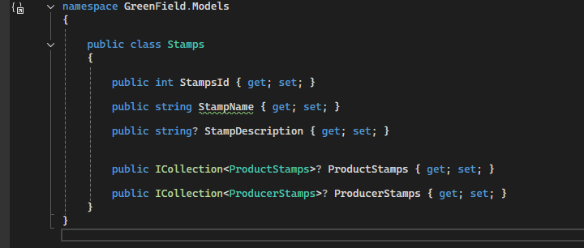I then scaffolded my models out with views and controllers. By keeping model, controller and view files in their own folders I am promoting organisation and mitigating the chance of the project getting unorganised.
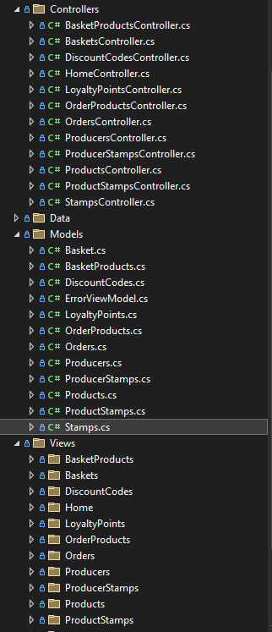Then I added my first migration called InitialCreate as this is the industry standard, then updated my database.
Today i:
- Created my solution
- Created my models
- Scaffolded my models into views and controllers
Tomorrow I want to:
- Seed Data for the models
- Seed roles
- Add google authentication for logging in#
Day 2:
Today I started by seeding data for Products, Producers, Discount codes, Stamps. After this I then seeded the different roles I wanted in my solution and demo accounts for these roles so I can test features relating to each role.
- Normal
- Producer
- Staff
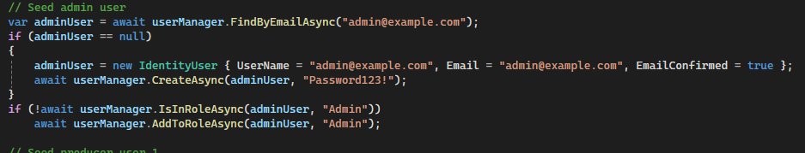
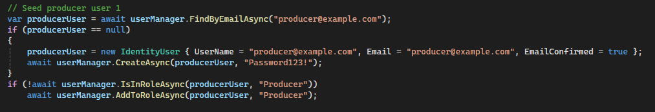
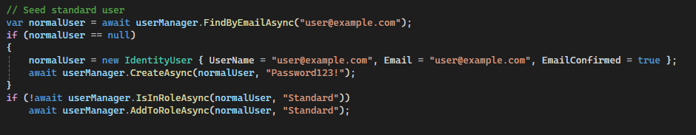
Today i:
- Seeded data for my models
- Seeded roles
- Seeded demo accounts for those roles
Tomorrow I want to:
- Create Basket Controller Logic
- Create products controller Logic
- Sort out my checkout function
- Create demo logo for the producers’ seed data
Day 3:
Today i started off by creating the logo for the seeded accounts using photoshop
After creating the logo I updated the seed data so the logo is used for all demo producers.
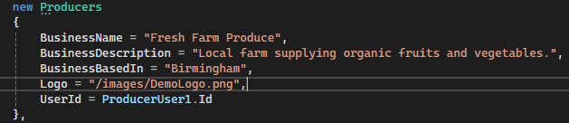
After this I then tackled the baskets controller logic, creating the functions for the basket to act like an actual basket and to display the contents of the basket not the basket itself, I then added the price logic. For the products controller I created the button for the products to be able to be added to basket.
I noticed when adding a product to basket the solution redirects the user to the basket immediately every time, to fix this I had to use AJAX to send the request without leaving the current page.
I also noticed that the basket page wouldn’t update and I had to implement an update button that would make the page save any changes that was made to it at the moment, for example, if you were in the basket page and clicked the plus button to increase quantity for an item you would have to press the update button which would reload the page to make it save an update the price.
so to fix this I implemented a silent tick that resaves and updates the basket page automatically after a certain amount of time using AJAX.
I also noticed that items could be duplicated in a basket when clicked to be added to the basket more than once, so I made an update so it just increases the quantity for that item instead
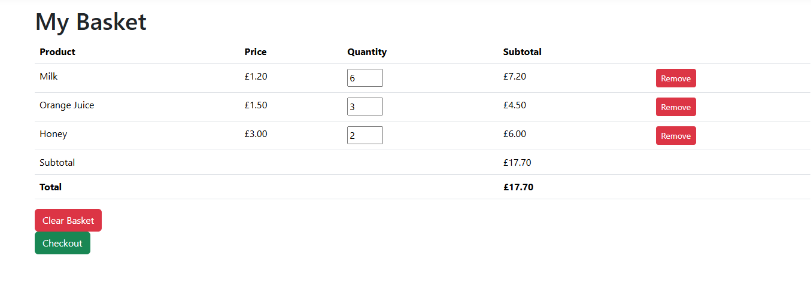
Then after fixing that I created a checkout process where the checkout button navigates to the order creation page, sourcing all the items in the basket, and asks the user if they want delivery or checkout, depending on that decision they can enter their address or choose their pickup date, and from there they can finish their checkout, once they are done they receive a confirmation and then they can proceed with their shopping.
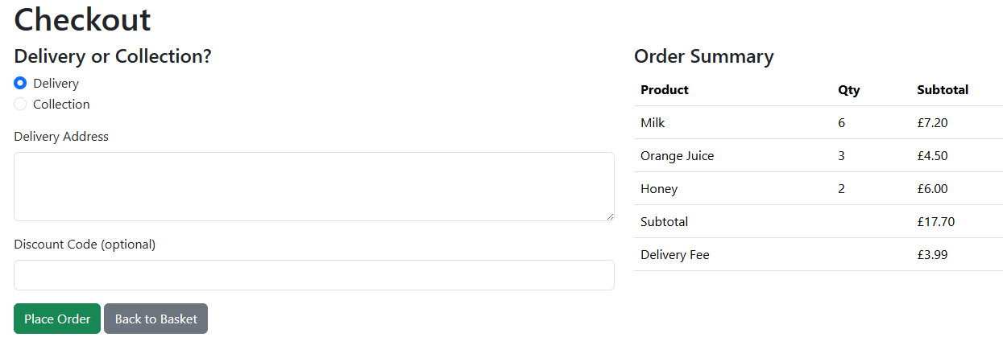
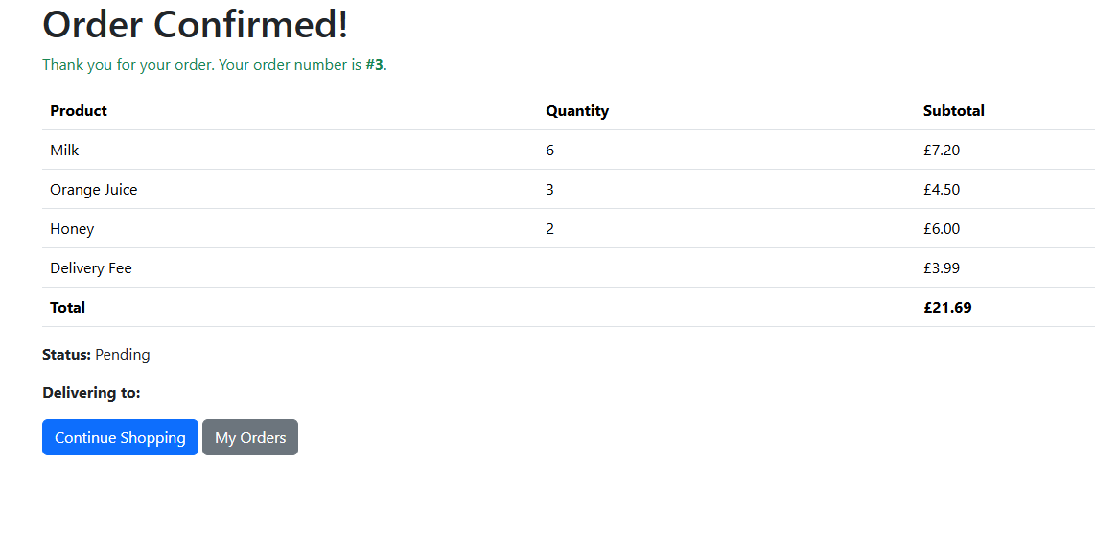
I noticed that the order was able to be confirmed without a delivery address being entered or a date being picked, so I added confirmation for both to fix that issue.

